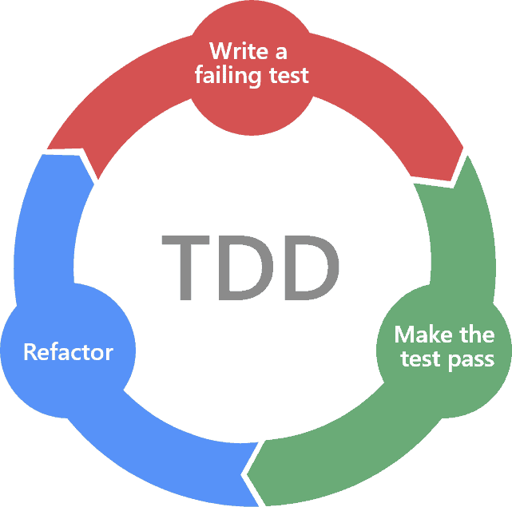

# Case Study: Vacuum Cleaner

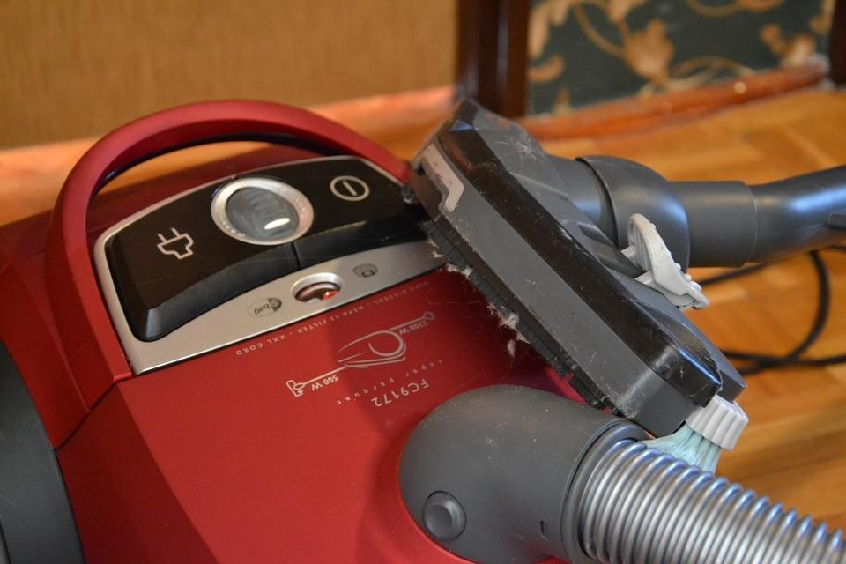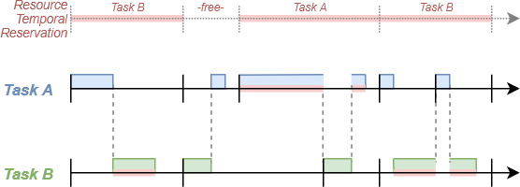**Speed Control**

# Timeline



Submission

Onsite

Interview

Internship

Start

**Before March 12 –**

**End of Day**

**March 20 – Full day Max April 1**

**Case Study: Vacuum Cleaner Speed 2**

**Challenge: Vacuum Cleaner Speed**

**Control**

**Motor Driver**

**Switches Data**

**Speed Control Module**

**Switches Driver**

**Target Angle**

**Challenge: Vacuum Cleaner Speed**

**Control – Description**

* Develop the “speed control” module such that:
  + The design follows a time triggered approach
  + Design is implemented using test-driven development approach
  + Used test design techniques are:
    - Equivalence partitioning
    - Boundary value analysis
    - State transition testing up to 1-switch coverage

# Suggested Readings



Time-Triggering Reference



Test-Driven Development Reference



Testing Techniques Reference

**Vacuum Cleaner Speed Control**

**Specifications**

* There are 3 speeds: minimum, medium and maximum speeds
* Default speed = medium
* There are 3 switches that can control the speed: “+ve”, “-ve” and “p”
* If “+ve” switch is pre-pressed, speed increases by 1 step if speed ! = maximum
* If “-ve” switch is pre-pressed, speed decreases by 1 step if not speed ! =

minimum

* If “p” switch is pressed for 30 seconds, speed decreases by 1 step if not

speed ! = minimum

* Priority of switches is:
  + “p” switch
  + “-ve” switch
  + “+ve” switch

# Motor Angles Specifications

* The speed control sets the motor angle according to the speed
  + Minimum speed ➔ 140 degrees
  + Medium speed ➔ 90 degrees
  + Maximum speed ➔ 10 degrees

# Tools

* Code::Blocks v20.03
* Unity C Test Harness
* CMock is a plus

# Deliverables

* Your CV
* Full project folder (speedcontrol_firstname_secondname.zip)
* Doxygen Documentation (doxygen_firstname_secondname.zip)
  + Source code documentation
  + Test documentation including testing techniques used for every test case
  + This should be in HTML format

# How to Simulate HW on PC?

* A text file will simulate the switches data (switch.txt)

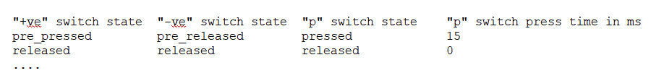

* Another text file will store the set motor angle (motor.txt)

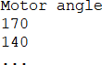

* Both files should be inside the project folder structure and the project should run without problems
* Every line should correspond to a test case

# How to Simulate HW on PC? cont’d

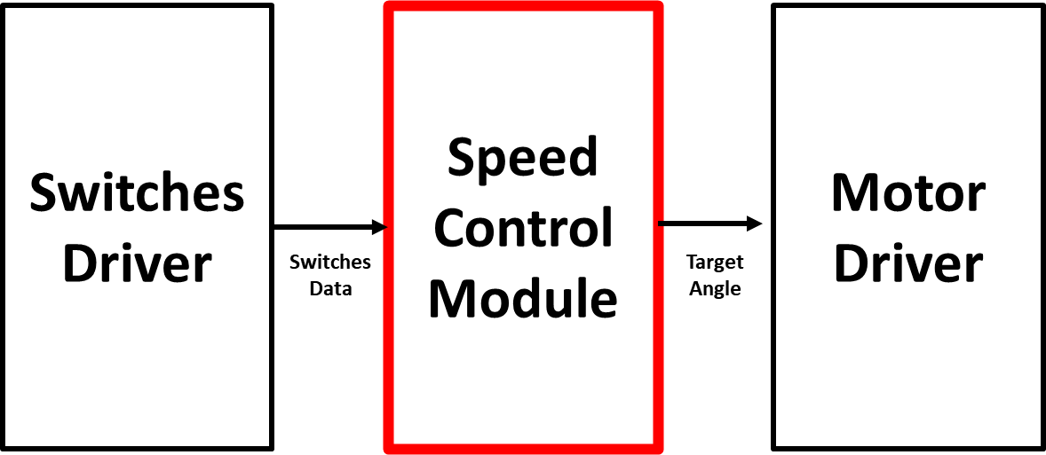

**Switches.**

**txt**

**Motor.txt**

**Case Study: Vacuum Cleaner Speed 11**

# How We Evaluate?

1. CV quality, if OK we go to
2. Doxygen folder, if OK we go to
3. Project folder (correct operation + code quality)

# We will

* Conduct 1 concept session to explain an example module developed by

TDD - Feb 26th

* Conduct 1 session to speak about last internship wave – March 3rd
* To contact us:
  + [www.swift-act.com](http://www.swift-act.com/)
  + [training@swift-act.com](mailto:training@swift-act.com)

**Case Study: Vacuum Cleaner Speed 14**